Past Exam Questions
Section 9.5

- If the system 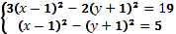 has a solution in the first Quadrant, then is equal to

- The number of intersections in the graph of the equations and is

- If and are the solutions of the system
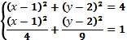
then

- The number of solutions of the system
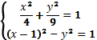
is equal to: (Hint: Sketch the graphs of the equations)

- The number of intersection points of the graph of the equations and is equal to:

- The graphs of the equations 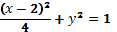 and intersect at:

  - Three points
  - Two points
  - No point
  - Four points
  - One point

- If and are eliminated from the system 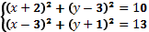 , we get:

- If and satisfy the system of the equations
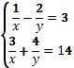
then is equal to

